Sunday Monday Tuesday Wednesday Thursday Friday Saturday
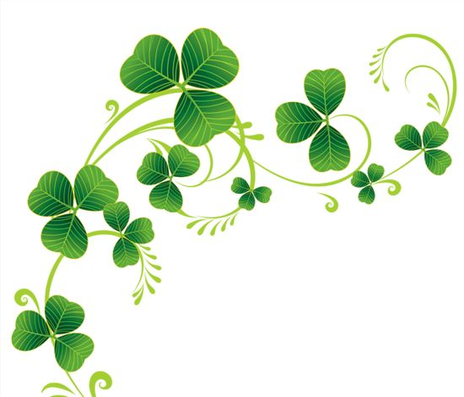 Pawtucket Lane March Welcome To Ireland!

 |  |  | 1  9:30 Morning Gathering 10:00 Welcome To Ireland  10:30 Morning Refreshment  11:00 Exercise  2:00 The “If You're Lucky Enough To Be Irish... You're Lucky Enough” Happy Hour!  3:30 Carol Burnette Show | 2  9:30 Morning Gathering 10:00 Bus to Mass  10:30 Morning Refreshment  11:00 Exercise  1:00 St Patrick’s Day Door  Hanging  2:30 Afternoon Refreshments  3:30 Walking Club | 3  9:30 Morning Gathering 10:00 Good News  10:30 Morning Refreshment  11:00 Exercise  1:00 Bingo  2:00 Stations of The Cross.  2:30 Afternoon Refreshments  3:30 Puzzles and Games | 4  9:30 Morning Gathering 10:00 Good News!  10:30 Morning Refreshment  11:00 Rosary  1:00 Exercise  2:30 Afternoon Refreshments  3:30 Adult Coloring
5  9:30 Morning Gathering 10:00 Did You Know?  10:30 Morning Refreshment  11:00 CTV Mass  1:00 Exercise  2:30 Afternoon Refreshments  3:30 Sing Along | 6  9:30 Morning Gathering  10:00 Cornhole  10:30 Morning Refreshment  11:00 Exercise  1:00 Cooking W/Louann  St. Patrick's Day Cookies  2:30 Afternoon Refreshments  3:30 Chicken Soup For The Soul  3:30 Chicken Soup for the Soul | 7  9:30 Morning Gathering  10:00 Communion  10:30 Morning Refreshment  11:00 Exercise  1:00 St Patrick's Day Centerpieces  2:30 Afternoon Refreshments  3:30 Manicures | 8 International Women’s Day  9:30 Morning Gathering 10:00 International Women’s  Day History and Trivia  10:30 Morning Refreshment  11:00 Exercise  2:00 Sounds of the Emerald Isle  Happy Hour  3:30 Dick Van Dyke Show | 9  9:30 Morning Gathering 10:00 Bus to Mass  10:30 Morning Refreshment  11:00 Exercise  1:00 St Patrick's Day Bracelets  2:30 Afternoon Refreshments  3:30 Walking Club | 10  9:30 Morning Gathering 10:00 Virtual Tour Of Ireland  10:30 Morning Refreshment  11:00 Exercise  1:00 Bingo  2:00 Stations of The Cross  2:30 Afternoon Refreshments  3:30 Puzzles and Games | 11  9:30 Morning Gathering 10:00 Angel Stories  10:30 Morning Refreshment  11:00 Rosary  1:00 Exercise  2:30 Afternoon Refreshments  3:30 Adult Coloring
12  9:30 Morning Gathering 10:00 Fill In The Blank  10:30 Morning Refreshment  11:00 CTV Mass  1:00 Exercise  2:30 Afternoon Refreshments  3:30 Sing along | 13  9:30 Morning Gathering 10:00 Hangman  10:30 Morning Refreshment  11:00 Exercise  1:00 Void Painting Tapestry  2:30 Afternoon Refreshment  3:30 Chicken Soup for the Soul | 14  9:30 Morning Gathering  10:00 Irish Step Dance Performance  (Video)  10:30 Morning Refreshment  11:00 Exercise  1:00 Country Drive (Trip)  2:30 Afternoon Refreshments  3:30 Manicures  Celtic and Clovers Irish Brunch | 15  9:30 Morning Gathering 10:00 We're All Irish On St. Patrick’s Day History/ Activity  10:30 Morning Refreshments  11:00 Exercise  1:00 Irish Game of Rings  2:30 Afternoon Refreshments  3:30 Lawrence Welk Show | 16  9:30 Morning Gathering 10:00 Bus to Mass  10:30 Morning Refreshment  11:00 Exercise  1:00 Stain Glass Celtic Cross  2:00 Resident Council  3:30 Walking Club | 17 Happy St Patrick’s Day  9:30 Morning Gathering 10:00 Irish Folklore  10:30 Morning Refreshment  11:00 Exercise  1:00 Bingo  2:00 Stations of The Cross  2:30 Afternoon Refreshments  3:30 Puzzles and Games  Lucky Leprechaun Noontime Luncheon | 18  9:30 Morning Gathering  10:00 Good News!  10:30 Morning Refreshments  11:00 Rosary  1:00 Exercise  2:30 Afternoon Refreshments  3:30 Adult Coloring
19  9:30 Morning Gathering 10:00 Did You Know?  10:30 Morning Refreshment  11:00 CTV Mass  1:00 Exercise  3:30 Sing Along | 20  9:30 Morning Gathering 10:00 Darts  10:30 Morning Refreshments  11:00 Exercise  1:00 Cooking W/ Louann  Making Irish Rice Crispy  Treats  3:30 Chicken Soup for the Soul | 21 Happy Birthday Judy!  9:30 Morning Gathering 10:00 Communion  10:30 Morning Refreshment  11:00 Exercise  1:00 The Pawtucket Lane Irish Pub  Event  3:30 Manicures | 22  9:30 Morning Gathering  10:00 Making Irish Potato  Candy  10:30 Morning Refreshments  11:00 Exercise  1:00 Butterfly Button Collage  2:30 Afternoon Refreshments  3:30 The And Griffith Show | 23  9:30 Morning Gathering  10:00 Bus To Mass  10:30 Morning Refreshment  11:00 Exercise  2:00 Shamrocks and Shenanigans  Happy Hour Featuring Chris  Collins  3:30 Walking Club | 24  9:30 Morning Gathering 10:00 Celtic Women Concert  (video)  10:30 Morning Refreshment  11:00 Exercise  1:00 Bingo  2:00 Stations of The Cross  2:30 Afternoon Refreshments  3:30 Puzzles and Games | 25  9:30 Morning Gathering 10:00 Angel Stories  10:30 Morning Refreshment  11:00 Rosary  1:00 Exercise  2:30 Afternoon Refreshments  3:30 Adult Coloring
26  9:30 Morning Gathering 10:00 Fill In The Blank  10:30 Morning Refreshment  11:00 CTV Mass  1:00 Exercise  3:30 Sing along | 27  9:30 Morning Gathering 10:00 Madlibs  10:30 Morning Refreshment  11:00 Exercise  1:00 Quilting Projects  2:30 Afternoon Refreshments  3:30 Chicken Soup for the Soul | 28  9:30 Morning Gathering  10:00 Guess Who  10:30 Morning Refreshments  11:00 Exercise  1:00 Top Donut Tuesday(Trip)  2:30 Afternoon Refreshments  3:30 Manicures | 29  9:30 Morning Gathering  10:00 Group Ipads  10:30 Morning Refreshments  11:00 Exercise  1:00 Leprechauns Race To The  Rainbow  2:30 Afternoon Refreshments  3:30 The Andy Griffith Show | 30 Happy Birthday Terry!  9:30 Morning Gathering  10:00 Bus To Mass  10:30 Morning Refreshment  11:00 Exercise  1:00 Shamrock Shakes and Some  Truth or Blarney  3:30 Walking Club | 31  9:30 Morning Gathering  10:00  10:30 Morning Refreshment  11:00 Exercise  1:00 Bingo  2:00 Stations of The Cross  2:30 Afternoon Refreshments  3:30 Puzzles and Games

