SPECIAL NOTES: | SUNDAY | MONDAY | TUESDAY | WEDNESDAY | THURSDAY | FRIDAY | SATURDAY
PLEASE NOTE: BASED ON THE NATURE OF THE SPECIAL CARE UNIT  ACTIVITIES ARE SUBJECT TO CHANGE PENDING THE DAILY ROUTINE OF OUR  RESIDENTS…. |  |  |  | 1  9:15 Morning Greeting  10:00 Coffee Social  10:45 Musical Memories  1:30 Ambience Sounds  2:00 Song Writing  3:00 Refreshment  3:30 White Board Game | 2  9:15 Morning Greeting  10:00 Coffee Social  10:45 Your Hit Parade  1:30 Prayers from the Heart  2:00 Balloon Toss  2:30 Refreshment  3:00 Painting & More  4:00 Picture This | 3 National Anthem Day  9:15 Morning Greeting  10:30 MASS  11:00 Classical Songs  1:30 Family Feud Trivia  2:00 Bingo / Sensory  3:00 Refreshment  3:30 Yesteryear | 4  9:15 Morning Greeting  10:00 Sing Along  11:00 Rosary  1:30 Name That Tune  2:15 Refreshment  3:00 Patterns & Designs  4:00 Amazing Facts
Relaxation Music  11:45am-12:45pm & 4:45pm-5:45pm | 5  9:15 Morning Greeting  10:00 MASS on TV/Hymns  11:00 Vintage Music  1:30 Opposites  2:15 Coffee Social  3:00 Exploring Places  4:00 Relaxing Music | 6  9:15 Morning Greeting  10:00 Coffee Social  10:45 Musical Memories  1:30 Alphabet Game  2:00 Movement & Music  3:00 Refreshment  3:30 Reminiscing Group | 7 Purim  9:15 Morning Greeting  10:00 Coffee Social  11:15 Jukebox Hits  2:00 Variety Show with  Peter Previte  3:00 Refreshment  3:30 Rosary | 8  9:15 Morning Greeting  10:00 Coffee Social  10:45 Musical Memories  1:30 Ambience Sounds  2:00 Song Writing  3:00 Refreshment  3:30 White Board Game | 9  9:15 Morning Greeting  10:00 Coffee Social  10:45 Your Hit Parade  1:30 Prayers from the Heart  2:00 Balloon Toss  2:30 Refreshment  3:00 Painting & More  4:00 Picture This | 10  9:15 Morning Greeting  10:30 MASS  11:00 Classical Songs  1:30 Family Feud Trivia  2:00 Bingo / Sensory  3:00 Refreshment  3:30 Yesteryear | 11  9:15 Morning Greeting  10:00 Sing Along  11:00 Rosary  1:30 Name That Tune  2:15 Refreshment  3:00 Patterns & Designs  4:00 Amazing Facts
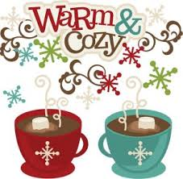 | 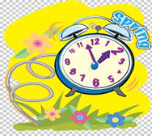 |  | 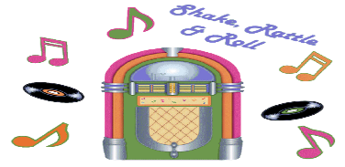 | 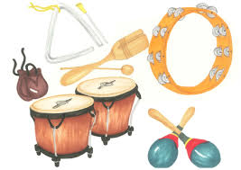 | 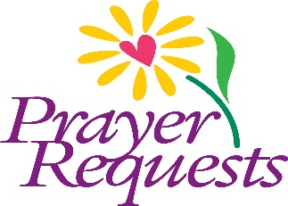 | 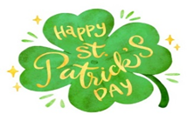 | 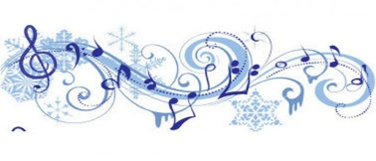
Extra Programs Offered  Sensory Room Programs  Small Groups  Men’s Group  1:1 Room Visits  Ipod with Headphones | 12 Daylight Saving Begins  9:15 Morning Greeting  10:00 MASS on TV/Hymns  11:00 Vintage Music  1:30 Opposites  2:15 Coffee Social  3:00 Exploring Places  4:00 Relaxing Music | 13  9:15 Morning Greeting  10:00 Coffee Social  10:30 Golden Retriever  & Jeff Visit  10:45 Musical Memories  2:00 Music by Ed  Dorazio  3:00 Refreshment  3:30 Reminiscing Group | 14  9:15 Morning Greeting  10:00 Coffee Social  11:15 Jukebox Hits  1:30 Name Five  2:00 Drum Circle  3:00 Refreshment  3:30 Rosary | 15  9:15 Morning Greeting  10:00 Coffee Social  10:45 Musical Memories  1:30 Ambience Sounds  2:00 Song Writing  3:00 Refreshment  3:30 White Board Game | 16  9:15 Morning Greeting  10:00 Coffee Social  10:45 Your Hit Parade  1:30 Prayers from the Heart  2:00 Balloon Toss  2:30 Refreshment  3:00 Painting & More  4:00 Picture This | 17 St. Patrick’s Day  9:15 Morning Greeting  10:30 MASS  11:00 Classical Songs  1:30 Family Feud Trivia  2:00 Bingo / Sensory  3:00 Refreshment  3:30 Yesteryear | 18  9:15 Morning Greeting  10:00 Sing Along  11:00 Rosary  1:30 Name That Tune  2:15 Refreshment  3:00 Patterns & Designs  4:00 Amazing Facts
Chapel  Prayer Service  Mondays 10:30am (CH 70)  MASS  Thursdays 10:30am (CH 70) | 19  9:15 Morning Greeting  10:00 MASS on TV /Hymns  11:00 Vintage Music  1:30 Opposites  2:15 Coffee Social  3:00 Exploring Places  4:00 Relaxing Music | 20 Spring Begins  9:15 Morning Greeting  10:00 Coffee Social  10:45 Musical Memories  1:30 Alphabet Game  2:00 Movement & Music  3:00 Refreshment  3:30 Reminiscing Group | 21  9:15 Morning Greeting  10:00 Coffee Social  11:15 Jukebox Hits  1:30 Name Five  2:00 Drum Circle  3:00 Refreshment  3:30 Rosary | 22  9:15 Morning Greeting  10:00 Coffee Social  10:45 Musical Memories  1:30 Ambience Sounds  2:00 Song Writing  3:00 Refreshment  3:30 White Board Game | 23  9:15 Morning Greeting  10:00 Coffee Social  10:45 Your Hit Parade  1:30 Prayers from the Heart  2:00 Balloon Toss  2:30 Refreshment  3:00 Painting & More  4:00 Picture This | 24  9:15 Morning Greeting  10:30 MASS  11:00 Classical Songs  1:30 Family Feud Trivia  2:00 Bingo / Sensory  3:00 Refreshment  3:30 Yesteryear | 25 Feast of the Annunciation  9:15 Morning Greeting  10:00 Sing Along  11:00 Rosary  1:30 Name That Tune  2:15 Refreshment  3:00 Patterns & Designs  4:00 Amazing Facts
Dining Piano Music  11:45am – 12:45pm  Mon. & Wed. Commodore  Tue. & Thurs. Appleton | 26  9:15 Morning Greeting  10:00 MASS on TV/Hymns  11:00 Vintage Music  1:30 Opposites  2:15 Coffee Social  3:00 Exploring Places  4:00 Relaxing Music | 27  9:15 Morning Greeting  10:00 Coffee Social  10:30 Golden Retriever  & Jeff Visit  10:45 Musical Memories  1:30 Alphabet Game  2:00 Movement & Music  3:00 Refreshment  3:30 Reminiscing Group | 28  9:15 Morning Greeting  10:00 Coffee Social  11:15 Jukebox Hits  1:30 Name Five  2:00 Drum Circle  3:00 Refreshment  3:30 Rosary | 29  9:15 Morning Greeting  10:00 Coffee Social  10:45 Musical Memories  1:30 Ambience Sounds  2:00 Song Writing  3:00 Refreshment  3:30 White Board Game | 30  9:15 Morning Greeting  10:00 Coffee Social  10:45 Your Hit Parade  1:30 Balloon Toss  2:30 Refreshment  3:00 Birthday Party with  Diane Dexter  4:00 Picture This | 31  9:15 Morning Greeting  10:30 MASS  11:00 Classical Songs  1:30 Family Feud Trivia  2:00 Bingo / Sensory  3:00 Refreshment  3:30 Yesteryear

