SPECIAL NOTES: | SUNDAY | MONDAY | TUESDAY | WEDNESDAY | THURSDAY | FRIDAY | SATURDAY
MUSIC THERAPY  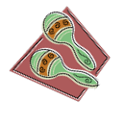 |  | 1 All Saints’ Day  9:15 Morning Greeting  10:00 Movement & Music  10:30 Prayer Service (ch70.1)  11:00 Opposites  1:30 Alphabet Game  2:00 Music Therapy  3:00 Puzzles  4:00 Reminiscing Group | 2  9:15 Morning Greeting  10:00 Balloon Toss  11:00 Jukebox Hits  1:30 Kickball  2:30 Drum Circle  3:30 Amazing Facts | 3  9:15 Morning Greeting  10:00 Bend & Stretch  11:00 Rosary  1:30 Ambience Sounds  2:00 Sing Along  3:00 White Board Game  4:00 Magazine Fun | 4  9:15 Morning Greeting  10:00 Sit Down Yoga  11:00 Your Hit Parade  1:30 Hymns  2:00 Prayers from the Heart  3:00 Travel Thru The State  4:00 Picture This | 5  9:15 Morning Greeting  10:15 MASS  11:00 Classical Music  1:30 Family Feud Trivia  2:15 Painting & More  3:00 Concert  4:00 Yesteryears | 6 Daylight Saving Time  9:15 Morning Greeting  10:00 Chair Exercise  11:00 Numbers Game  1:30 Name That Tune  2:15 Patterns & Designs  3:00 Music & Rhythm Fun  4:00 Rosary
 | 7  9:15 Morning Greeting  10:00 MASS on TV/Hymns  11:00 Vintage Music  1:30 Spiritual Time  2:15 Sports Games  3:00 Exploring Places  4:00 Relaxing Music | 8  9:15 Morning Greeting  10:00 Movement & Music  10:30 Prayer Service (ch70.1)  10:30 Golden Retriever  & Jeff Visit  1:30 Alphabet Game  2:00 Therapeutic Music  3:00 Puzzles  4:00 Reminiscing Group | 9  9:15 Morning Greeting  10:00 Balloon Toss  11:00 Jukebox Hits  1:30 Kickball  2:30 Therapeutic Music  3:30 Amazing Facts | 10  9:15 Morning Greeting  10:00 Bend & Stretch  11:00 Rosary  1:30 Ambience Sounds  2:00 Sing Along  3:00 White Board Game  4:00 Magazine Fun | 11 Veterans Day  9:15 Morning Greeting  10:00 Sit Down Yoga  11:00 Your Hit Parade  1:30 Hymns  2:00 Prayers from the Heart  3:00 Travel Thru The State  4:00 Picture This | 12  9:15 Morning Greeting  10:15 MASS  11:00 Classical Music  1:30 Family Feud Trivia  2:15 Painting & More  3:00 Concert  4:00 Yesteryears | 13  9:15 Morning Greeting  10:00 Chair Exercise  11:00 Numbers Game  1:30 Name That Tune  2:15 Patterns & Designs  3:00 Music & Rhythm Fun  4:00 Rosary
Extra Programs Offered  Sensory Room Programs  Small Groups  Men’s Group  1:1 Room Visits  Ipod with Headphones | 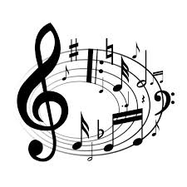 |  | 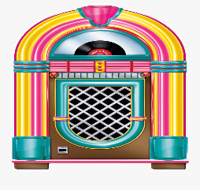 | 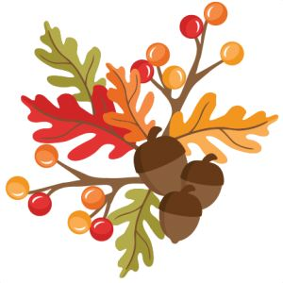 | 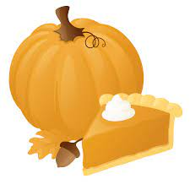 |  | 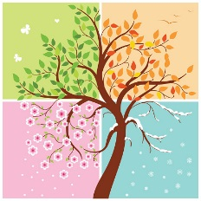
 | 14  9:15 Morning Greeting  10:00 MASS on TV/Hymns  11:00 Vintage Music  2:00 Music by  Ed Dorazio  3:30 Exploring Places  4:00 Relaxing Music | 15  9:15 Morning Greeting  10:00 Movement & Music  10:30 Prayer Service (ch70.1)  11:00 Opposites  1:30 Alphabet Game  2:00 Music Therapy  3:00 Puzzles  4:00 Reminiscing Group | 16  9:15 Morning Greeting  10:00 Balloon Toss  11:00 Jukebox Hits  2:00 Silent Film  & Sing Along  With Richard Hughes  3:30 Amazing Facts | 17  9:15 Morning Greeting  10:00 Bend & Stretch  11:00 Rosary  1:30 Ambience Sounds  2:00 Music Therapy  3:00 White Board Game  4:00 Magazine Fun | 18  9:15 Morning Greeting  10:00 Sit Down Yoga  11:00 Your Hit Parade  1:30 Hymns  2:00 Prayers From the Heart  3:00 Travel Thru The State  4:00 Picture This | 19  9:15 Morning Greeting  10:15 MASS  11:00 Classical Music  1:30 Family Feud Trivia  2:15 Travel Thru The State  3:00 Concert  4:00 Yesteryears | 20  9:15 Morning Greeting  10:00 Chair Exercise  11:00 Numbers Game  1:30 Name That Tune  2:15 Patterns & Designs  3:00 Music & Rhythm Fun  4:00 Rosary
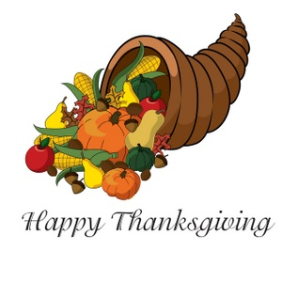 | 21  9:15 Morning Greeting  10:00 MASS on TV/Hymns  11:00 Vintage Music  1:30 Spiritual Time  2:15 Sports Games  3:00 Exploring Places  4:00 Relaxing Music | 22  9:15 Morning Greeting  10:00 Movement & Music  10:30 Prayer Service (ch70.1)  10:30 Golden Retriever  & Jeff Visit  1:30 Alphabet Game  2:00 Music Therapy  3:00 Puzzles  4:00 Reminiscing Group | 23  9:15 Morning Greeting  10:00 Balloon Toss  11:00 Jukebox Hits  1:30 Kickball  2:30 Therapeutic Music  3:30 Amazing Facts | 24  9:15 Morning Greeting  10:00 Bend & Stretch  11:00 Rosary  1:30 Ambience Sounds  2:00 Music Therapy  3:00 White Board Game  4:00 Magazine Fun | 25 Thanksgiving Day  9:15 Morning Greeting  10:00 Macy’s Parade  11:00 Hymns  2:00 Circle of Friends  3:00 Giving Thanks  4:00 Holiday Music | 26  9:15 Morning Greeting  10:15 MASS  11:00 Classical Music  1:30 Family Feud Trivia  2:15 Painting & More  3:00 Concert  4:00 Yesteryears | 27  9:15 Morning Greeting  10:00 Chair Exercise  11:00 Numbers Game  1:30 Name That Tune  2:15 Patterns & Designs  3:00 Music & Rhythm Fun  4:00 Rosary
PLEASE NOTE: BASED ON THE NATURE OF THE SPECIAL CARE UNIT  ACTIVITIES ARE SUBJECT TO CHANGE PENDING THE DAILY ROUTINE OF OUR  RESIDENTS…. | 28 Hanukkah Begins  First Sunday of Advent  9:15 Morning Greeting  10:00 MASS on TV/Hymns  11:00 Vintage Music  1:30 Spiritual Time  2:15 Sports Games  3:00 Exploring Places  4:00 Relaxing Music | 29  9:15 Morning Greeting  10:00 Movement & Music  10:30 Prayer Service (ch70.1)  11:00 Opposites  1:30 Alphabet Game  2:00 Music Therapy  3:00 Puzzles  4:00 Reminiscing Group | 30  9:15 Morning Greeting  10:00 Balloon Toss  11:00 Jukebox Hits  1:30 Kickball  2:30 Drum Circle  3:30 Amazing Facts

